**School of Media Arts and Technology**

BSc (Hons) [**Computing]**

**Academic Year 2020-2021**

**[Evon Agatha Lobo]**

**[Report/Artefacts]**

Dataset Analysis

**Data Science (COM618)**

**Part A**

1. Finding a dataset

The dataset I found is “heart failure clinical records”. The link to the dataset is: <https://archive.ics.uci.edu/ml/datasets/Heart+failure+clinical+records>. This study was conducted in July 2017 by Ahmad and his colleagues. They investigated medical records of 299 Pakistanis to determine key features of heart failure patients and to predict morality. (Chicco and Jurman, 2020)

The following consists of the attributes existing in this dataset:

* Age: how many years old the person is.
* Anaemia (Boolean): decrease in haemoglobin. Haematocrit level below 36% was considered anaemic.
* High blood pressure (Boolean): if the patient experiences hyper-tension or not.
* Creatinine phosphokinase (mcg/L): depicts the level of CPK enzyme in the blood. CPK at a high level in blood can cause a heart failure due to a damage in a muscle tissue causing CPK to flow into blood.
* Diabetes (Boolean): whether the person has diabetes or not.
* Ejection fraction (percentage): with each contraction of the heart, ejection fraction depicts how much (by percentage) does the left ventricle pump out.
* Platelets (kiloplatelets/mL): platelets count in the blood.
* Sex (binary): whether the person is male or female.
* Serum creatinine (mg/dL): the waste product formed when a muscle breaks down. A high count of creatinine in the blood could cause renal dysfunction.
* Serum sodium (mEq/L): heart failure could be cause by low levels of sodium in the blood
* Smoking (Boolean): if the person smokes or not.
* Time (days): follow-up period.
* Death Event (target): determines whether the person died or survived before 130 days (follow-up period).

(Chicco and Jurman, 2020)

1. Data Preparation

No obvious identifiers are present such as names, addresses, date of birth etc.

Data preparation or cleaning of data can be done by (Brownlee, 2020):

* **Identifying outliers**

I used Tableau’s “bubble chart” feature to check for any abandoned/far-away values. There are about 6 columns out of the 13 that are binary/boolean values. There is no point as such to check for outliers in these, nevertheless, I did so to make sure there are no wrong values other than 0 and 1. The following shows of these:

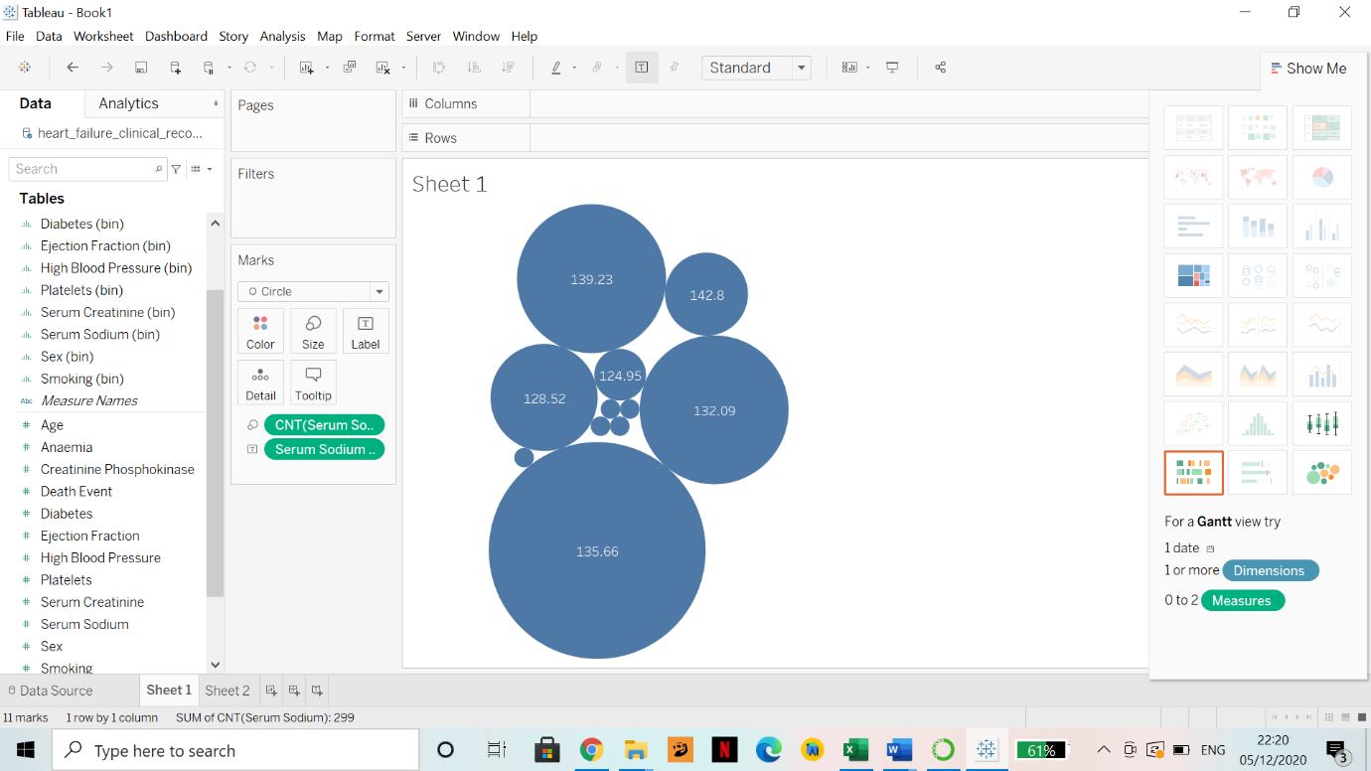

Figure 1: Serum Sodium levels. No existing outliers.



Figure 2: Platelets count. No existing outliers.

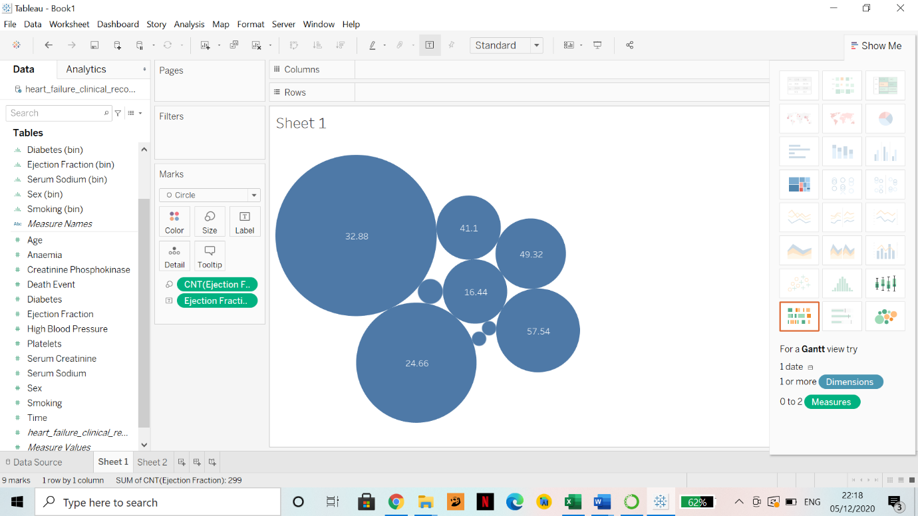

Figure 3: Ejection Fraction. No existing outliers.



Figure 4: Age. No existing outliers.



Figure 5: High Blood Pressure. (Boolean). No existing outliers.



Figure 6: Death Event. (Boolean). No existing outliers.



Figure 7: Anaemia. (Boolean). No existing outliers.



Figure 8: Smoking. (Boolean). No existing outliers.



Figure 9: Sex. (Boolean). No existing outliers.



Figure 10: Diabetes. (Boolean). No existing outliers.

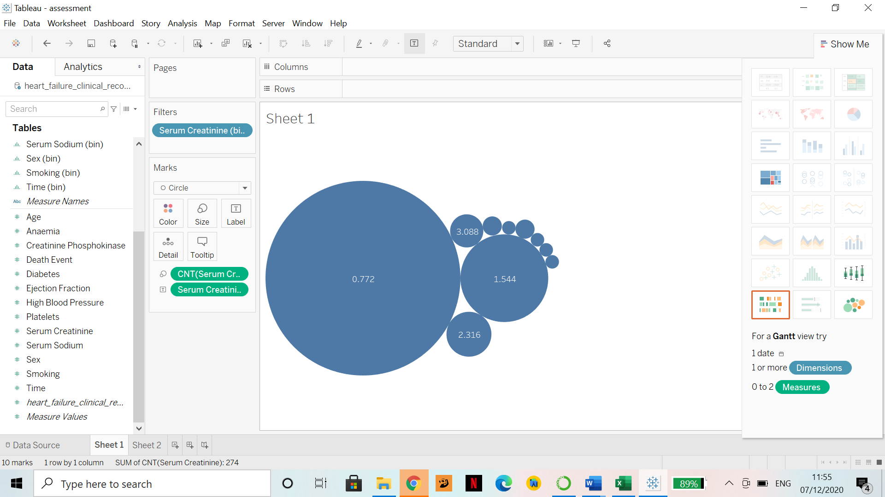

Figure 11: Time. No existing outliers.

For “**Time**”, the follow-up period varied between 4-285 days with an average of 130 days. (Ahmad et al., 2017). Hence, I checked the minimum, maximum, range, and average values of the “Time” column to confirm the previous statement made by Ahmad et. al., in excel as seen in Figure 12:

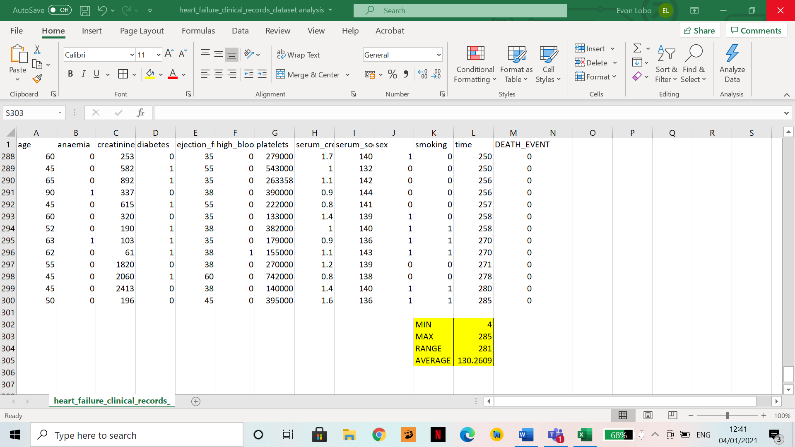

Figure 12: Min, max, average and range of the “Time column”

For “**Creatinine Phosphokinas**e” level in the blood, I tried to find outliers using the Bubble Chart feature on Tableau and encountered an error as seen in the figure below:

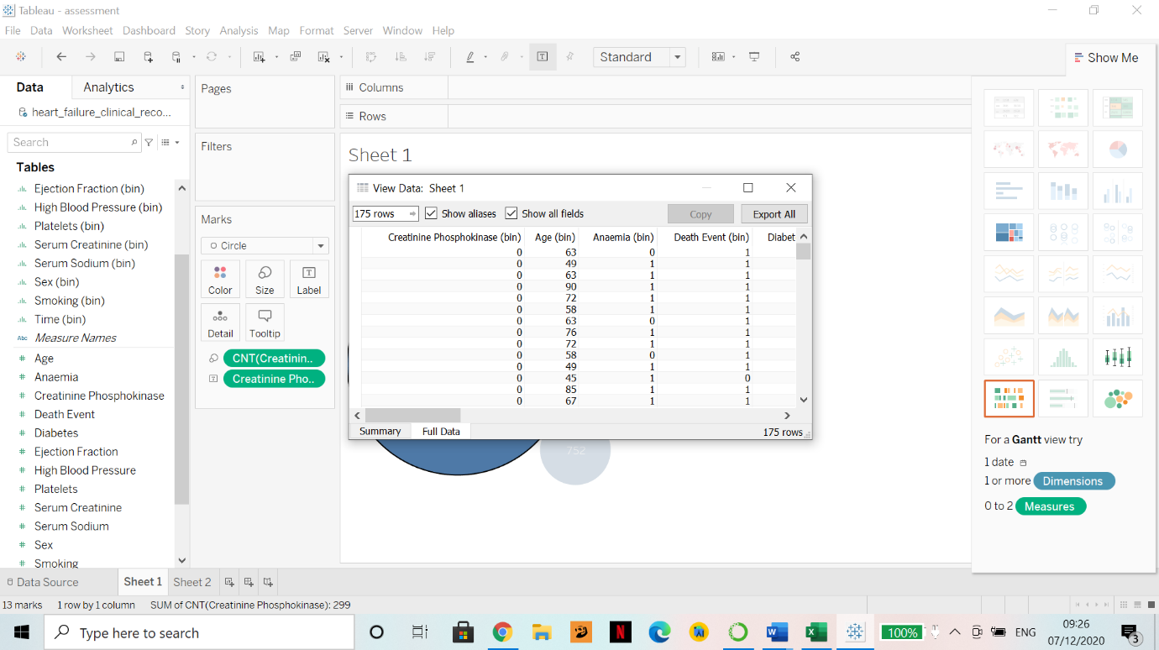

Figure 13: Error while finding outliers for CPK levels. 175 rows showed up as 0.

So, I decided to find the Minimum and Maximum value of CPK along with its range as seen in the figure below (highlighted):

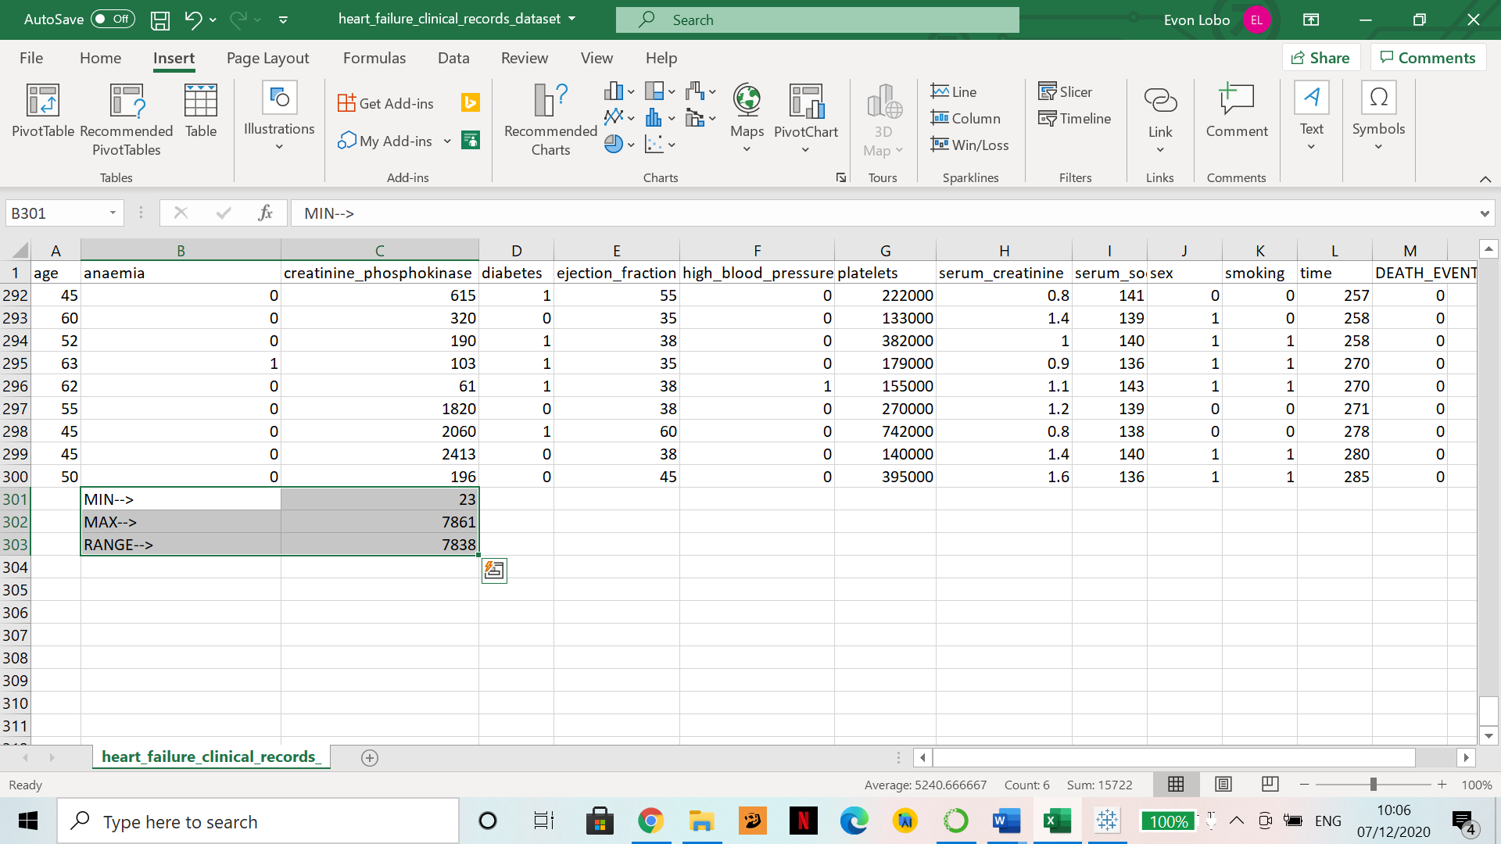

Figure 14: Minimum, maximum and range of CPK column

There was an issue with this that is discussed in III. B., in the section that follows.

* **Removing of columns that have single values or no variance**

To check for columns that have single values (zero-variance predictors) in order to delete them, I used Jupyter Notebook (Pandas).

Figure 14 shows the import of the dataset and figure 15 shows code for finding out unique values in each column.

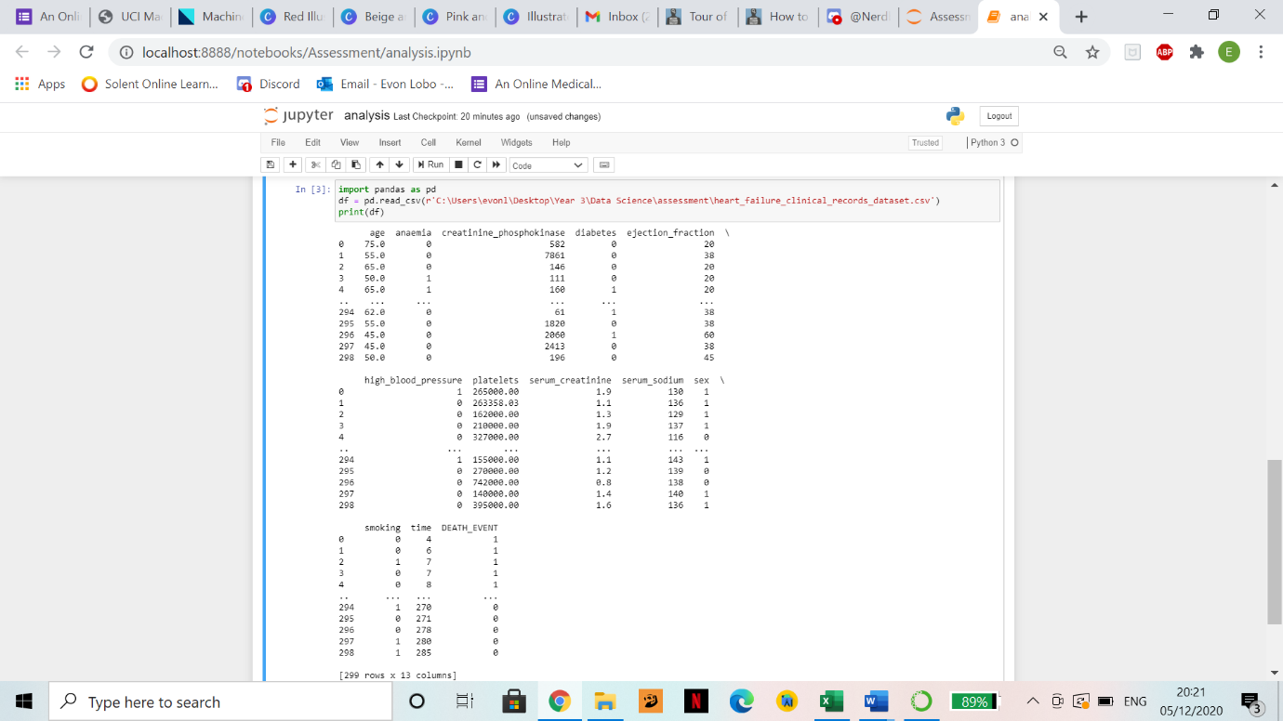

Figure 15: Import of heart failure clinical records dataset.

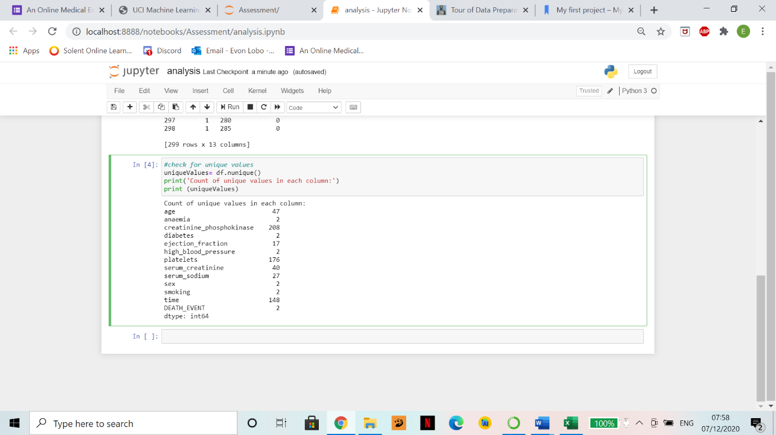

Figure 16: Checking for unique values in each column.

**Observation**

As seen in figure 15, there does not exist a column with only ONE value. The minimum range of values is 2 for the 6 columns that are boolean in this dataset. Hence no column/row was deleted further. The binary/Boolean columns are not filtered out as they can still be used to plot something like age against time grouped by smokers and non-smokers. As Kuhn and Johnson said “Although near-zero variance predictors likely contain little valuable predictive information, we may not desire to filter these out. These columns may or may not contribute to the skill of a model. We can’t assume that they are useless to modelling.” (Kuhn and Johnson, 2019, p.96-97).

* **Removing of duplicate rows**

I used Jupyter Notebook (Pandas) to check for any duplicate values, if any, for all columns except the binary ones as seen below:

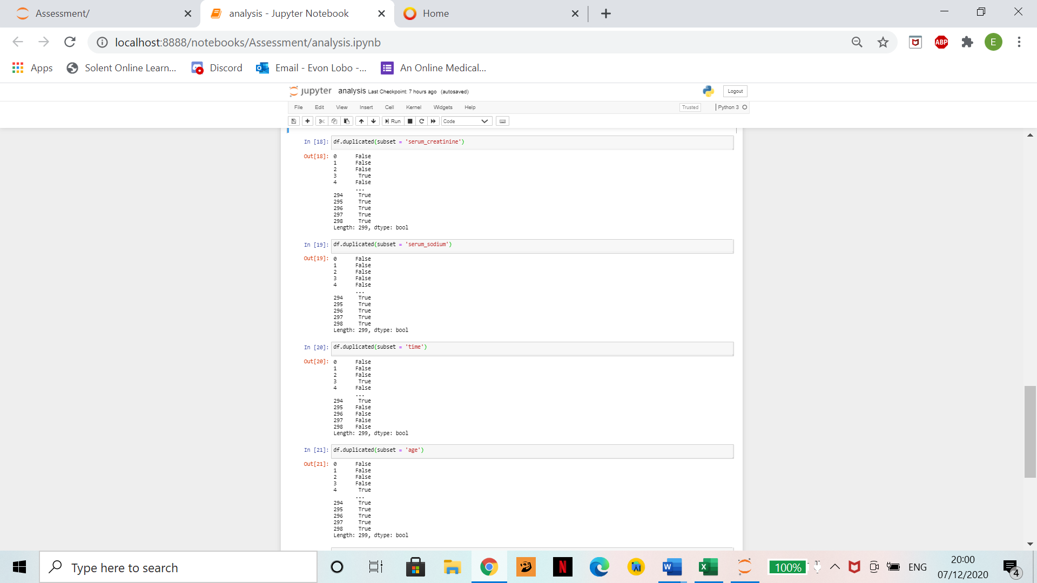

Figure 17: Checking for duplicates.

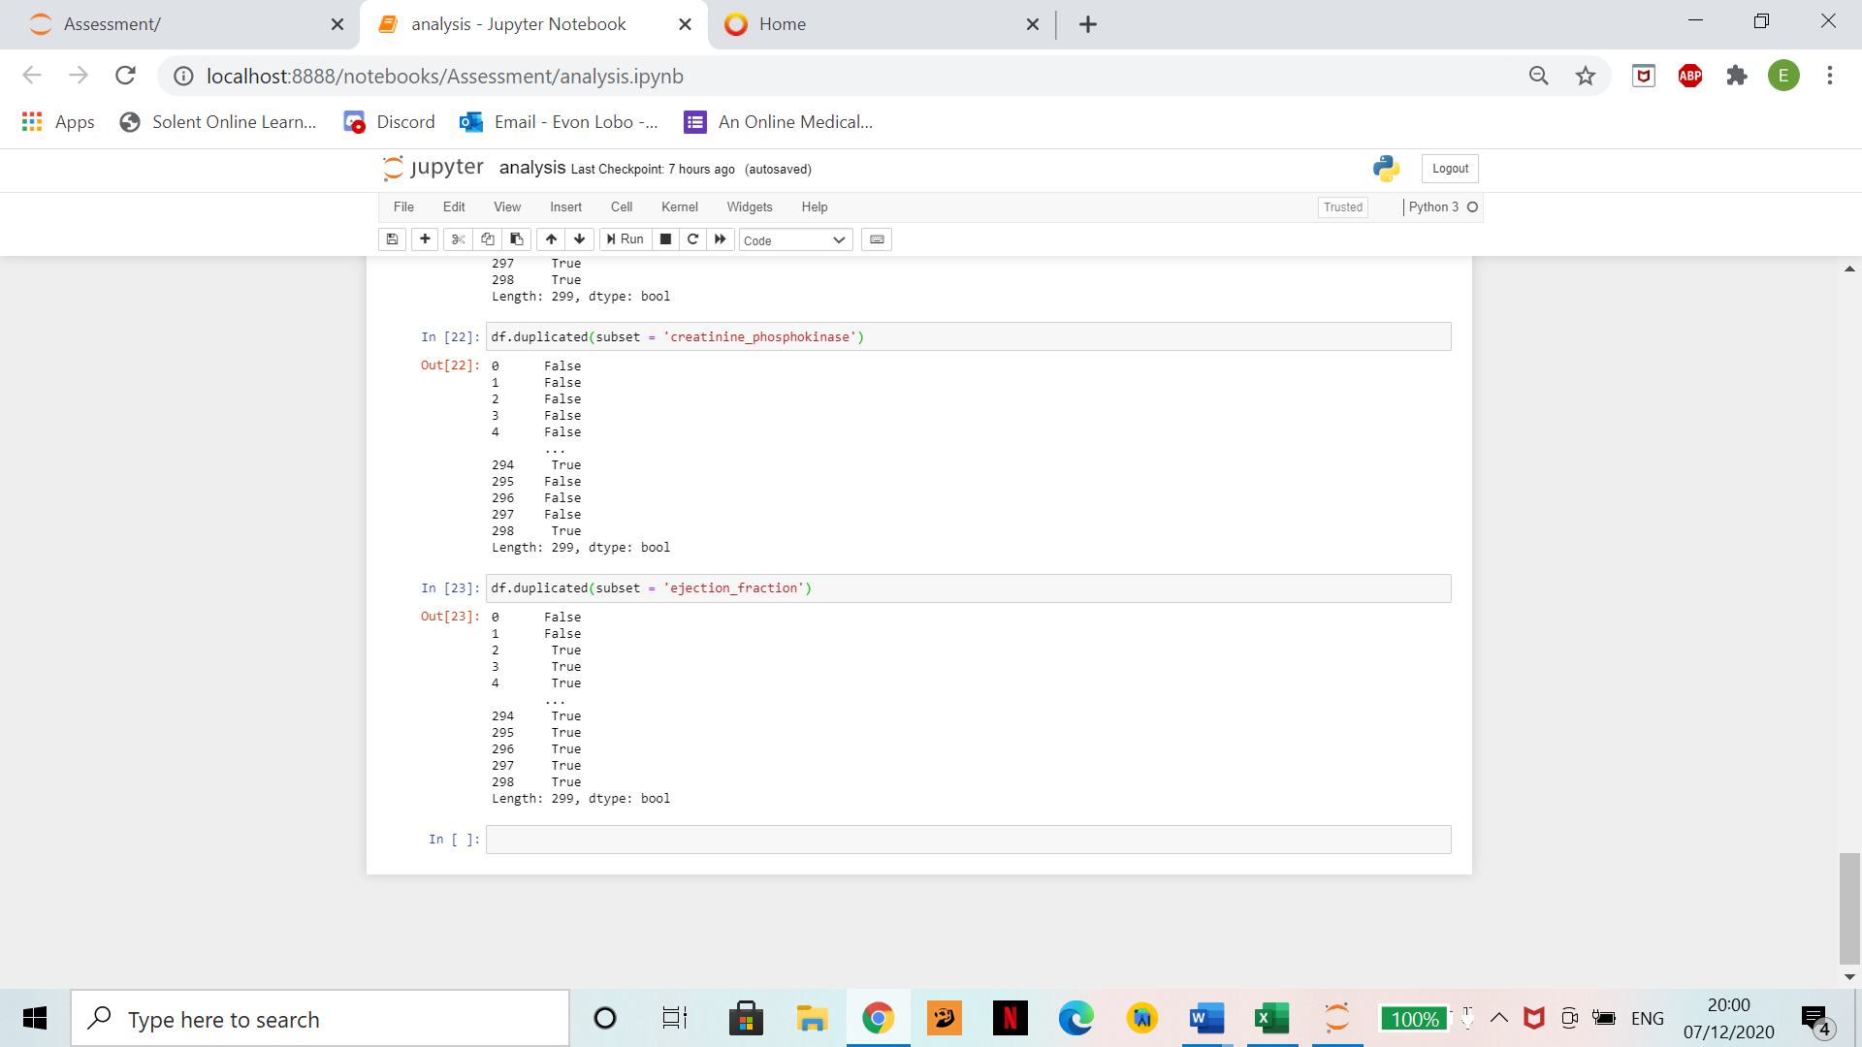

Figure 18: Checking for duplicates.

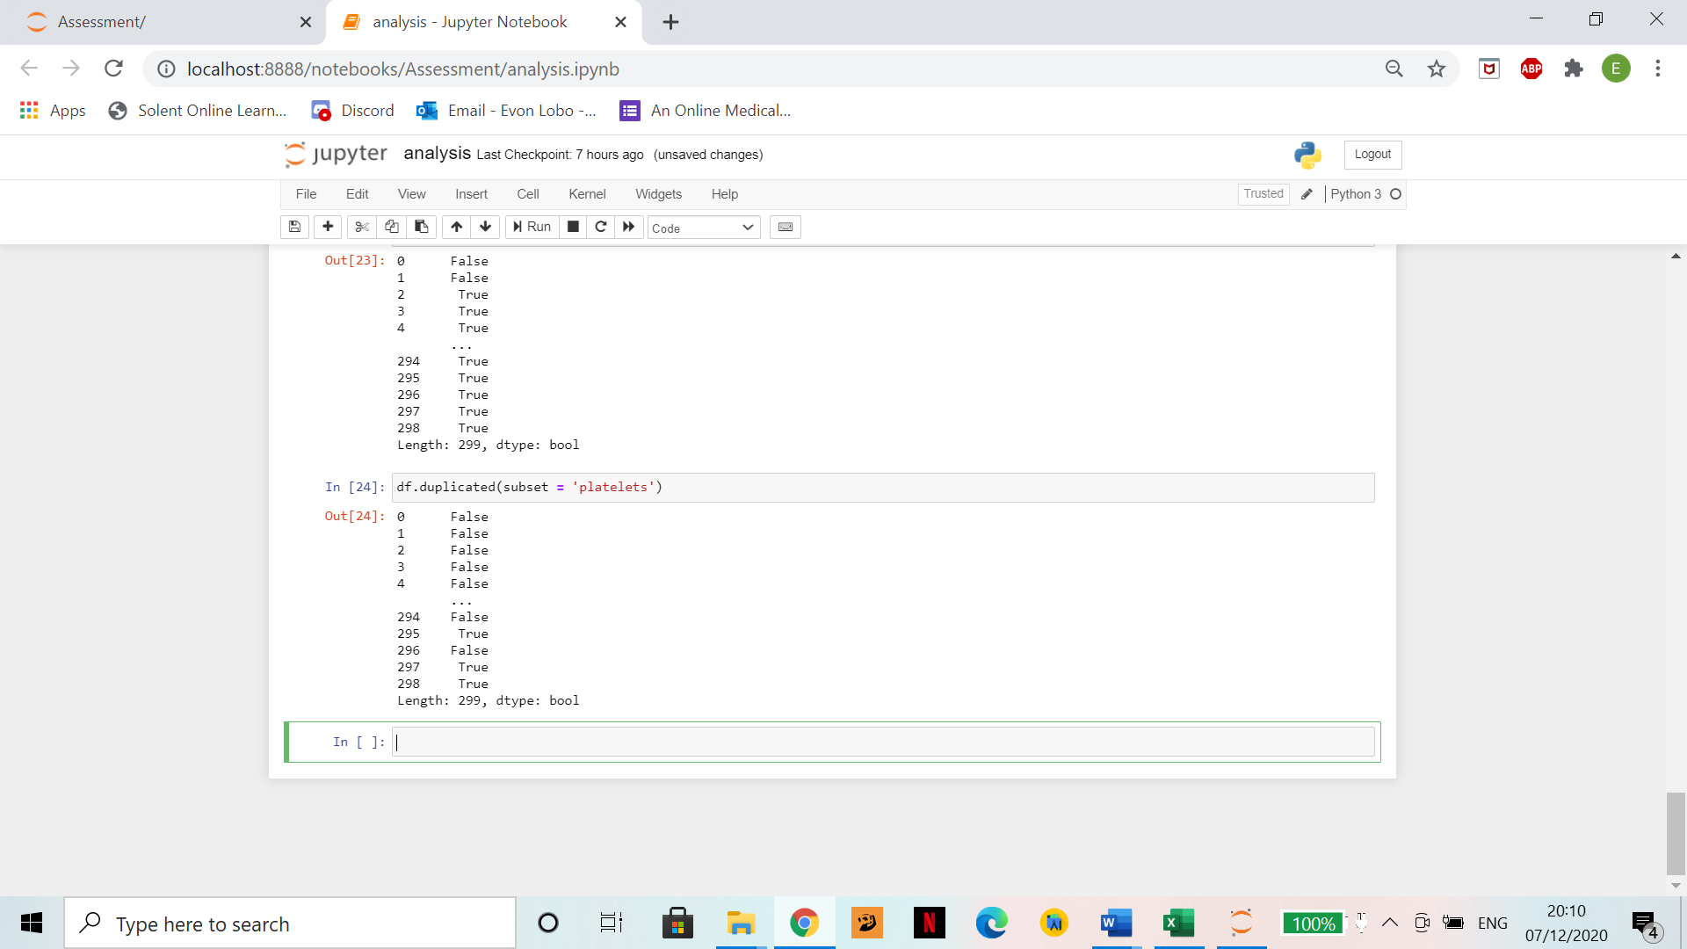

Figure 19: Checking for duplicates.

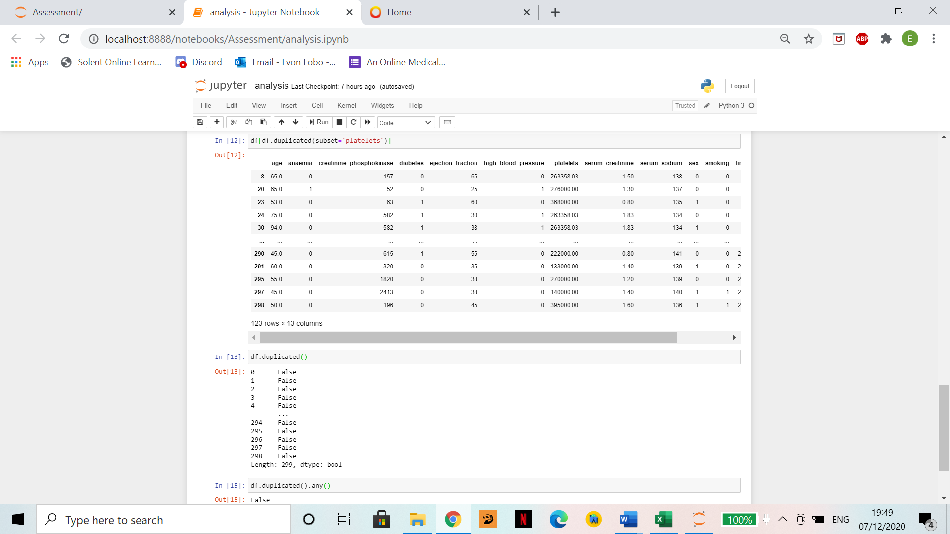

Figure 20: Line 15; checking for any rows that match each other(duplicates) across the dataset.

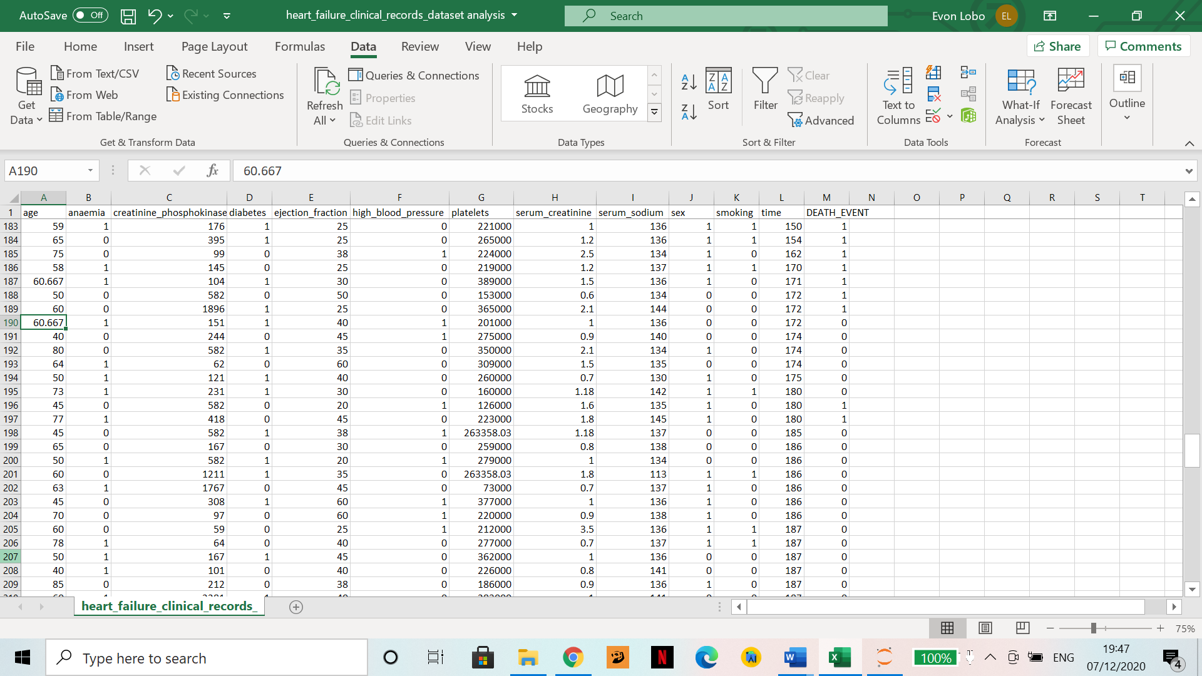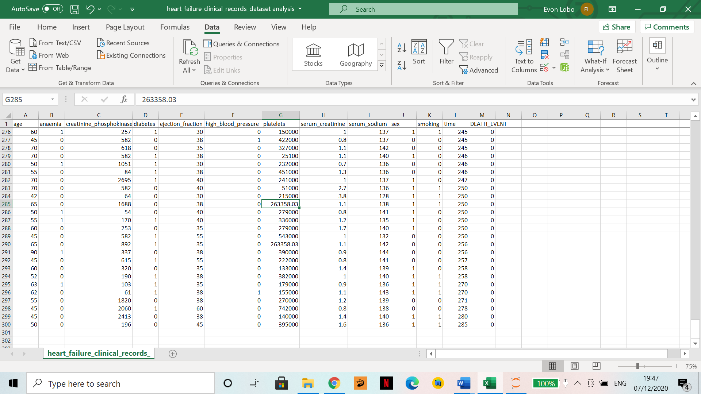

Figure 21 and 22: Averaged values.

**Observation**

All columns have duplicate values (figure 17-19). They were not deleted as they are relevant in this case i.e., two people can be of same age and can also have the same platelets count. If they were, for example, National ID instead, then two of the same value cannot exist and hence would be removed. Figure 20 proves that there are no two rows that are the exact same.

An observation; figure 21 and 22 show two values (Age: 60.667 and platelets: 263358.03) repeated more than once in their respected columns. These seem like they were missing values which were filled in with averaged values.

* **Mark empty values as missing**

I first used the command .isnull() to check for missing values on Jupyter Notebook (Pandas).

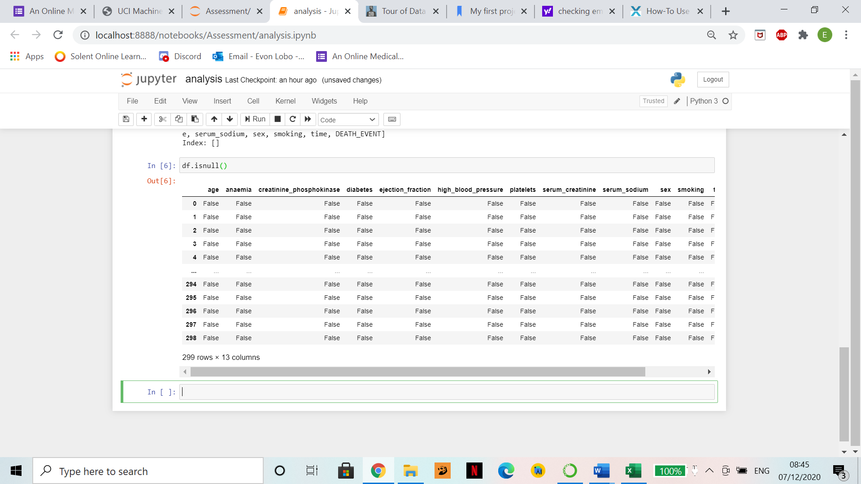

Figure 23: checking for null values.

**Observation**

All columns and rows are filled otherwise missing cells would contain “True”.

* **Fill in missing values using statistics**

I did not have to fill in any missing values since there were not any.

**Conclusion of Part II.**

This dataset did not contain outliers, empty values, identifiers etc., as seen above. Hence no modification was made during the cleaning process of this dataset.

1. Data Exploration
2. Mean, Median, Mode and Standard Deviation

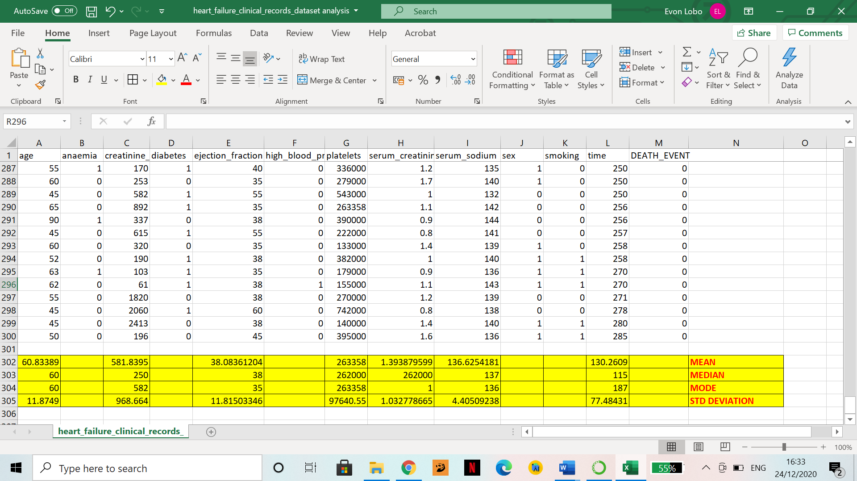

Figure 24: Mean, median, mode and standard deviation of all columns except the ones which possess binary data

1. CPK Levels:

I could not understand why there were values as high as 7000+ mcg/L for CPK levels and some as low as 23 mcg/L, so I did the following research:

The normal CPK levels in any human (male or female) ranges between 10-120 mcg/L.

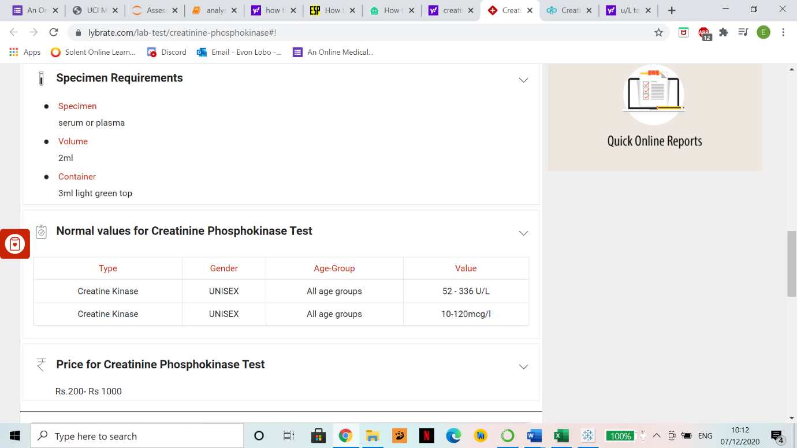

Figure 25: Normal range of CPK levels (Lybrate, n.d.). (Note: CK and CPK are equivalent).

The reason why levels of CPK is high for so many patients is “High levels of CPK usually indicate some sort of stress or injury to your heart or other muscles, since CPK leaks into your blood when muscle tissue is damaged.” (HTQ, 2018). This dataset is of patients that went through heart failure, so this answers why there are patients that have abnormally high levels of CPK.

I used Jupyter Notebook (Pandas) to see how many patients out of 299 had high CPK levels as seen in the figure below:

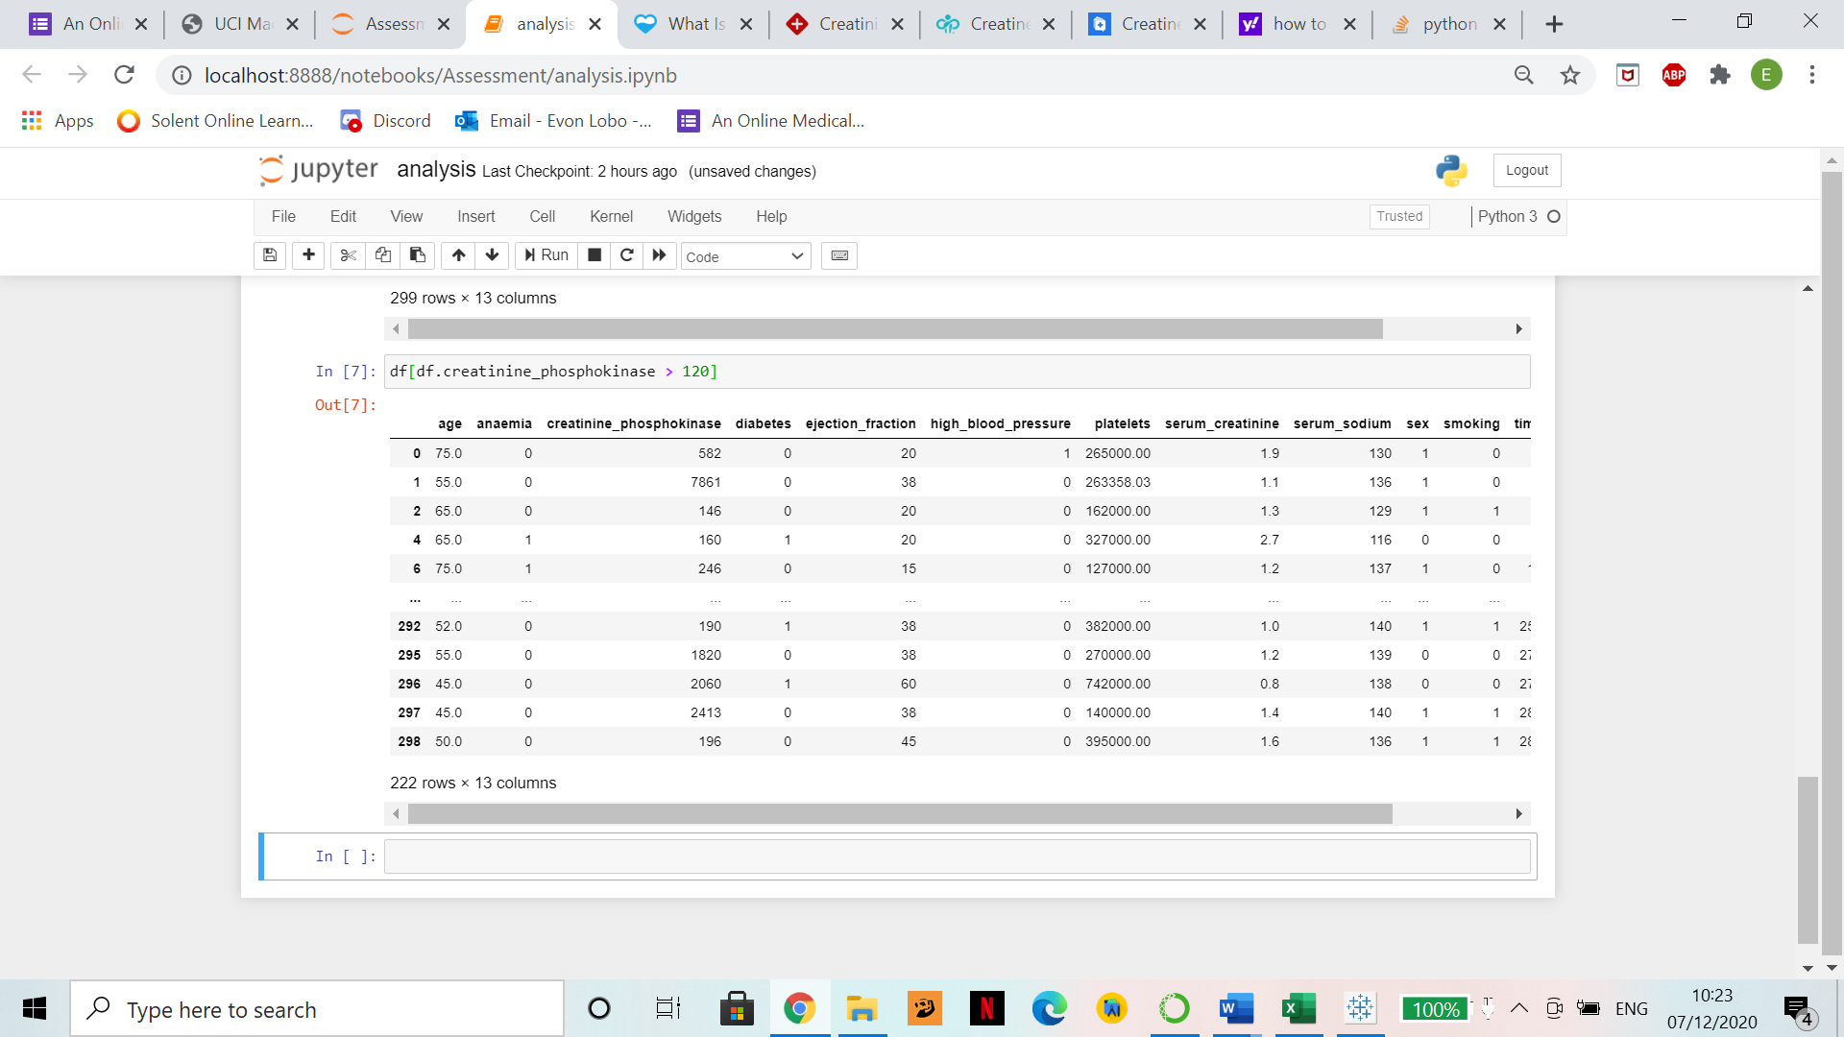

Figure 26: CPK levels above 120 mcg/L (max of normal range).

222 out of 299 patients had high CPK levels.

1. Histogram: age against number of records

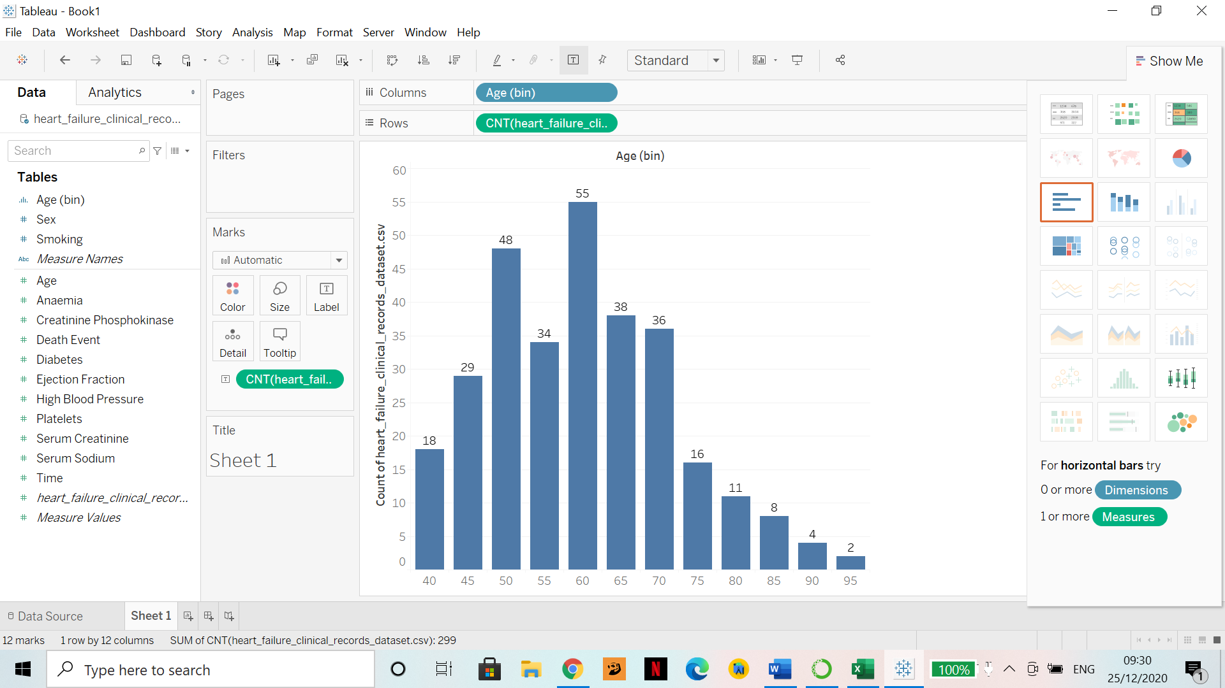

Figure 27: shows how many records exist with age classified into intervals of 5.

**Note**: Since all columns of the dataset were “Measures” (they are numerical), I converted binary data into dimensions and created bins out of age with intervals of 5.

1. Histogram: Age against number of records along with smokers and non-smokers count.

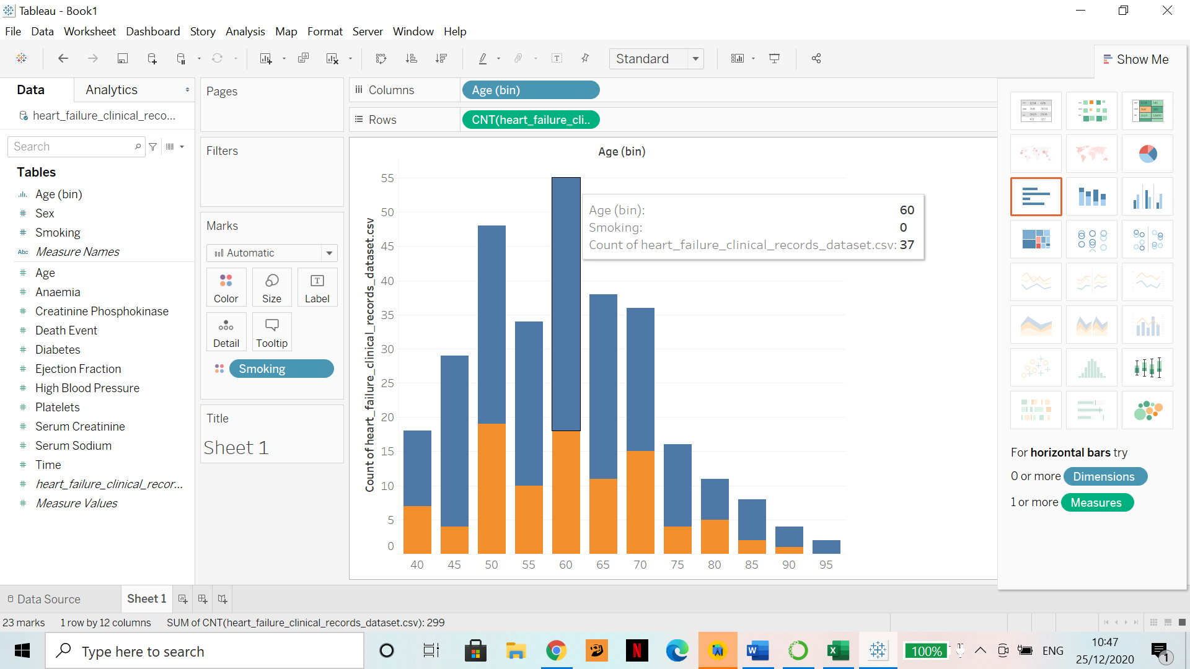

Figure 28: Blue marks those that did not smoke and orange marks those that did with age in intervals of 5

**Note**: 0 means false and 1 means true.

1. The following figures show the age group and combinations of people having/not having high blood pressure, smoking/not smoking, diabetes/no diabetes.

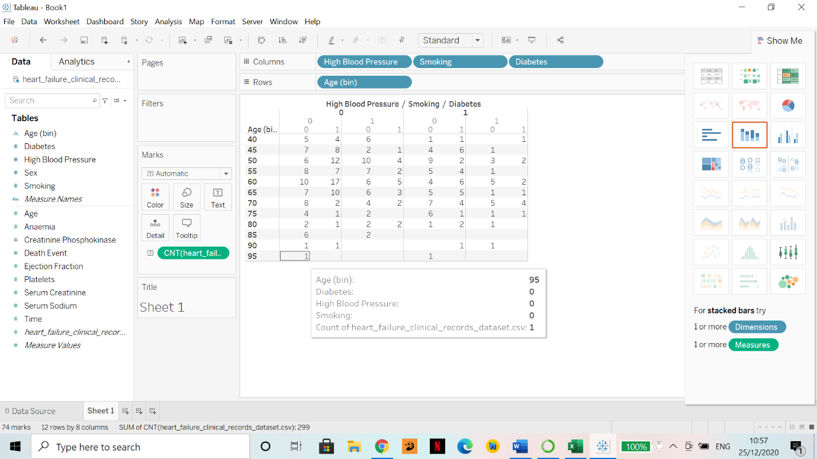

Figure 29.

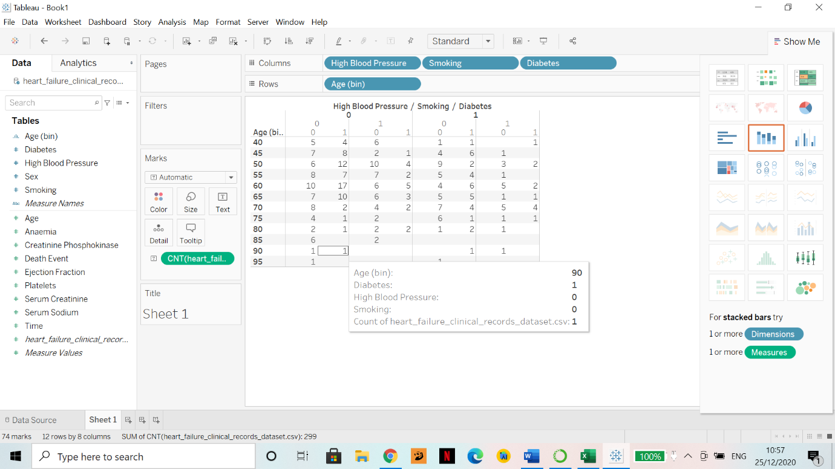

Figure 30.

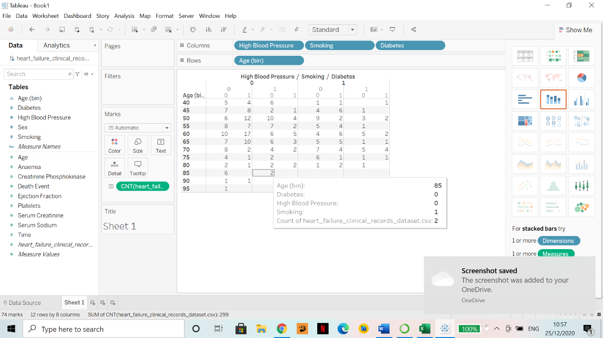

Figure 31.

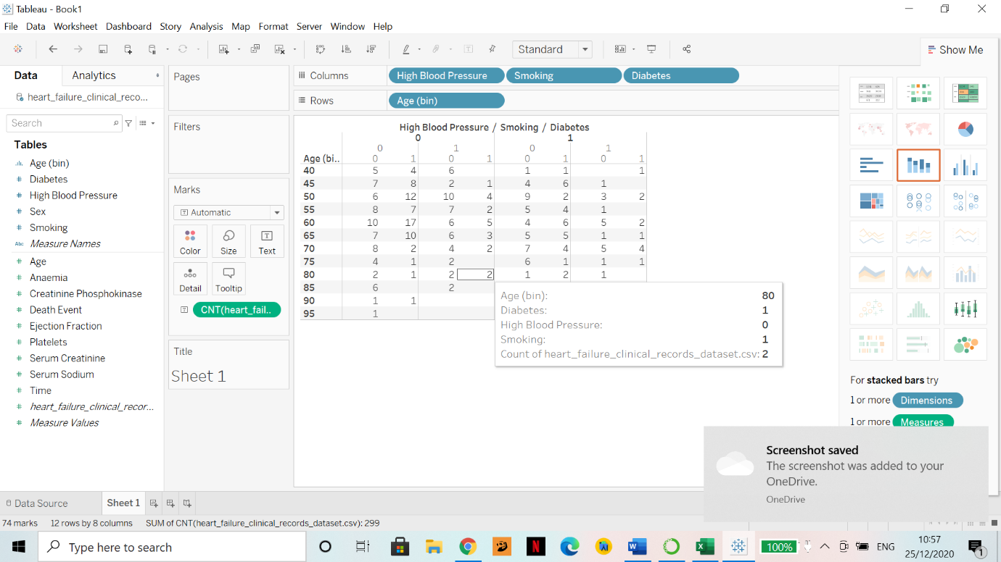

Figure 32.

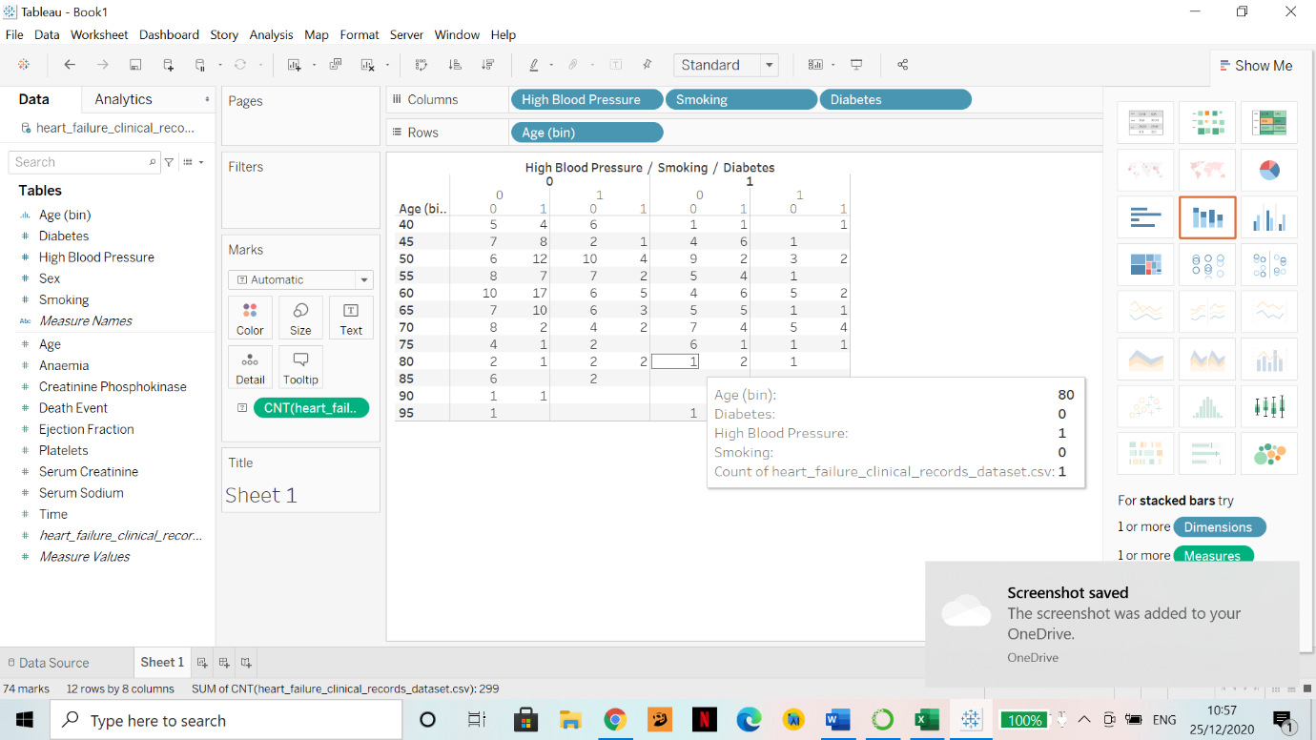

Figure 33.

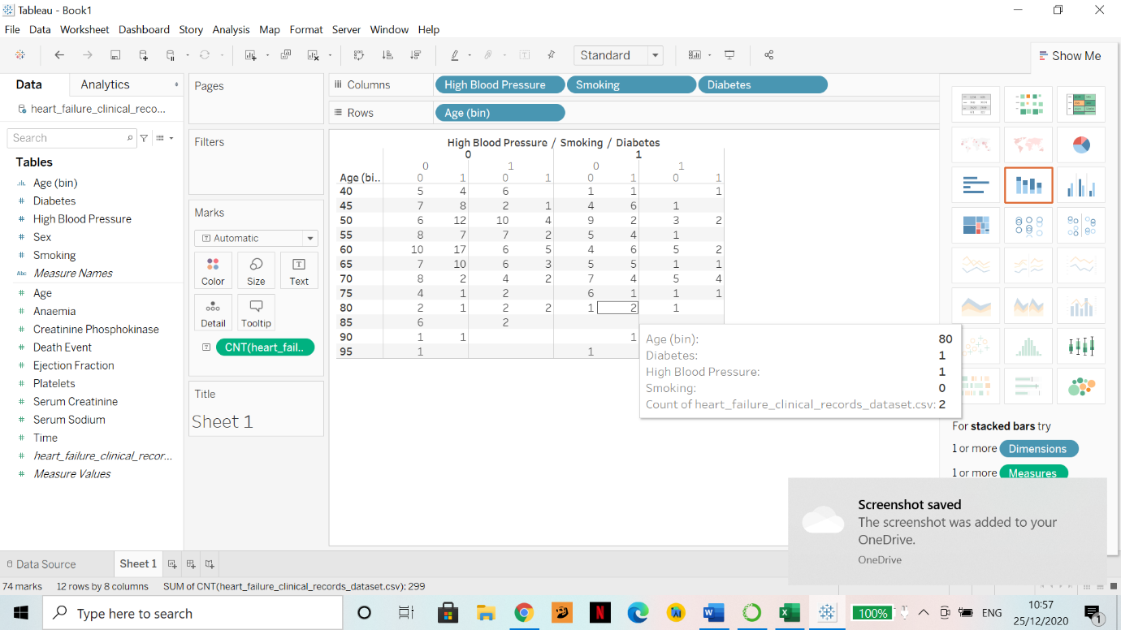

Figure 34.

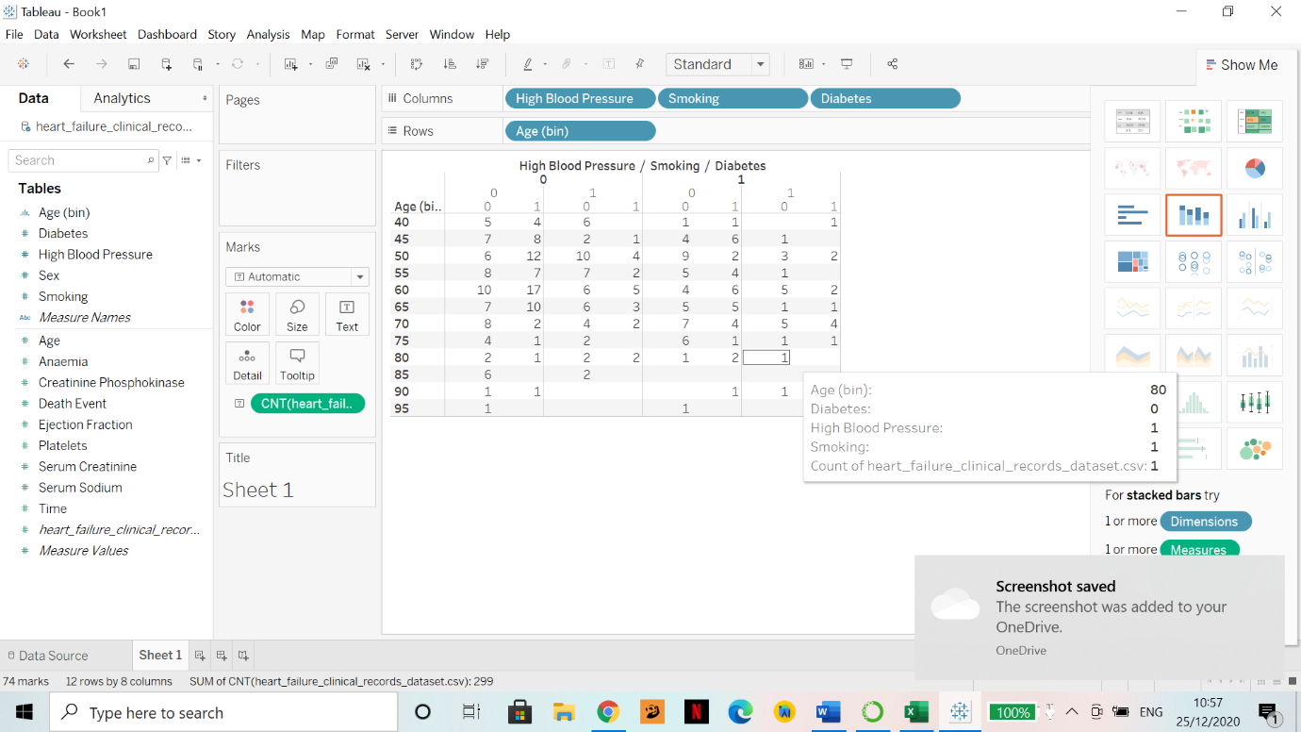

Figure 35.

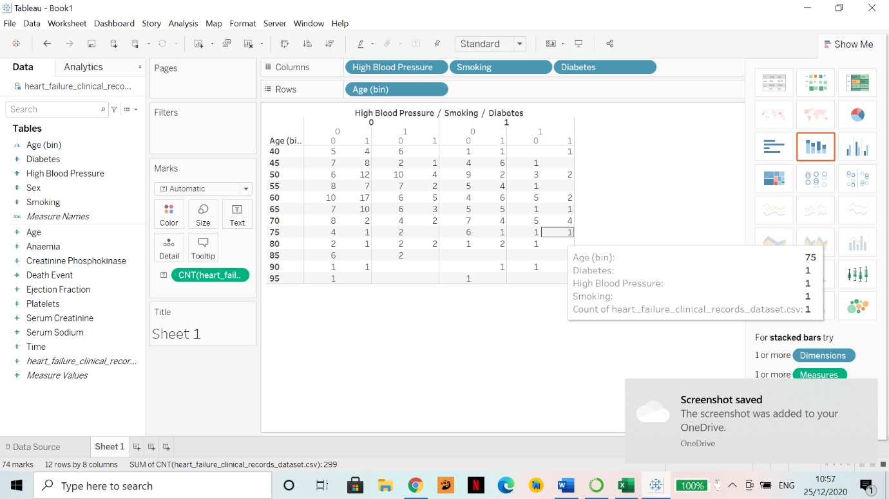

Figure 36.

Note: I hovered over every column to observe the output. For example in figure 36 there was 1 person aged 75 who had diabetes, high blood pressure and smoked.

**Part B.**

1. Data Modelling and Visualisation
2. I conducted linear regression modules between age (independent variable) against all dependent variables that were non-binary data as seen below:

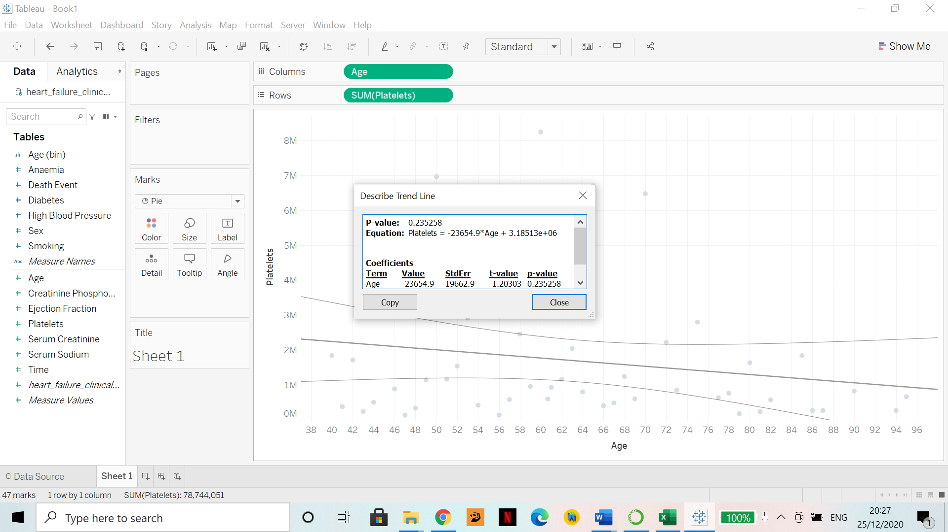

Figure 37.

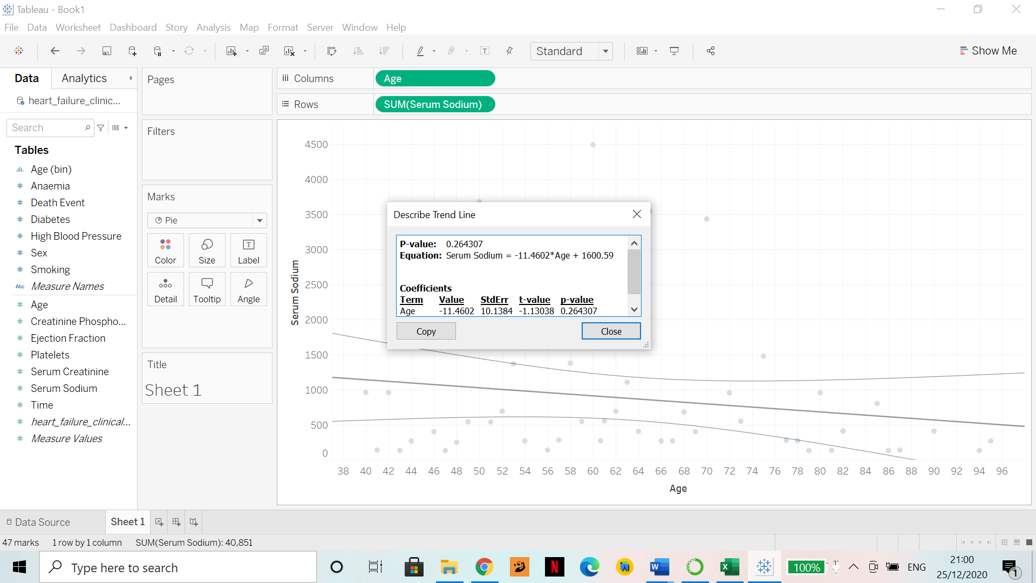

Figure 38.

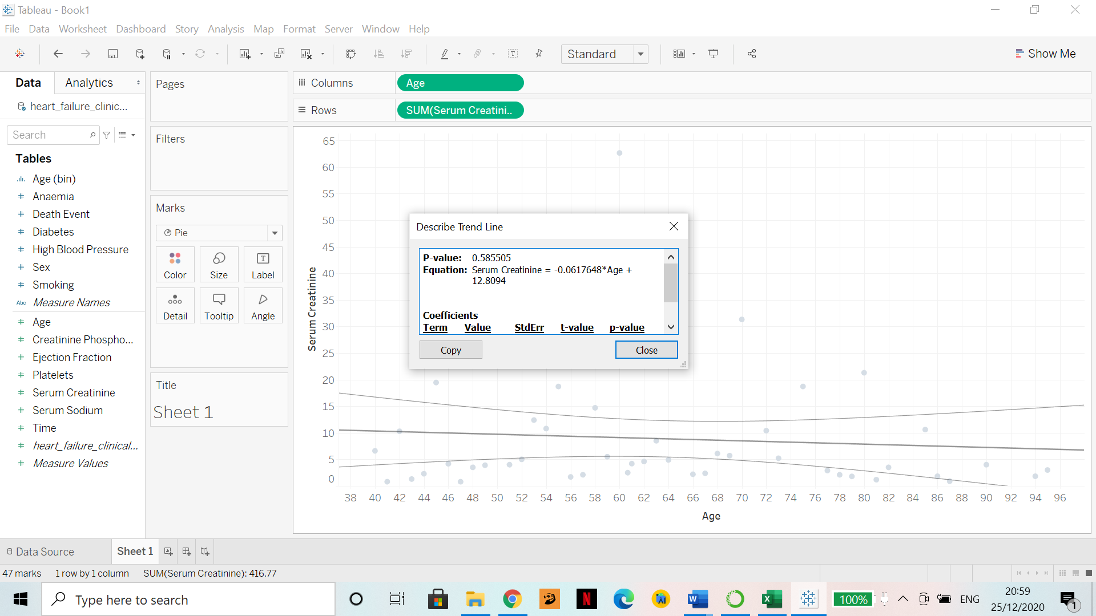

Figure 39.

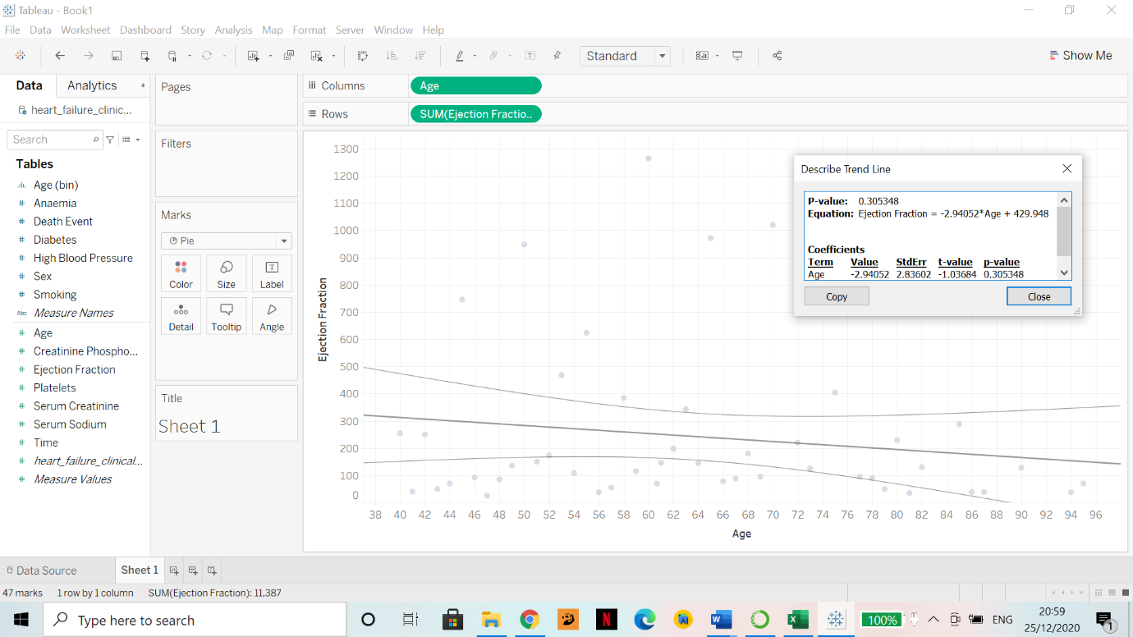

Figure 40.

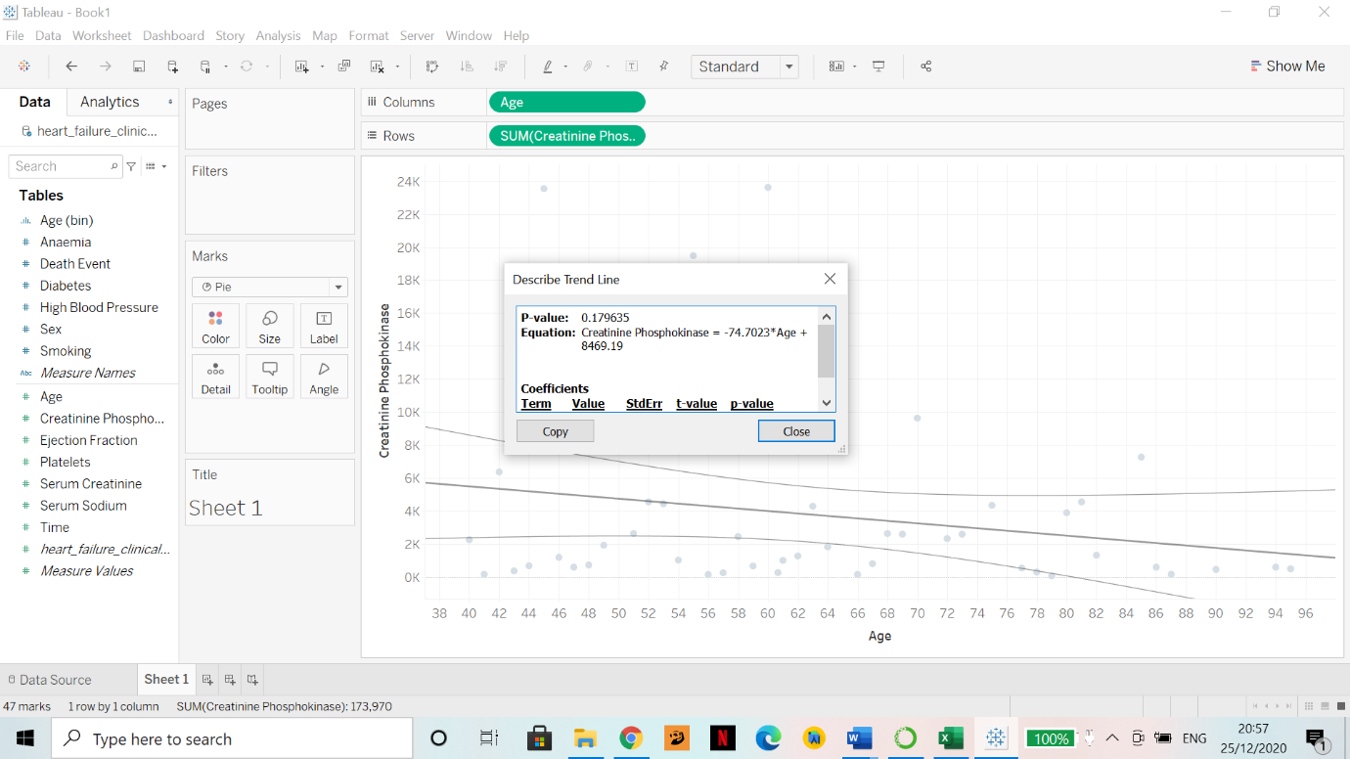

Figure 41.

**Observation**

It isevident that every variable i.e., serum creatinine, ejection fraction, platelets count, serum sodium and creatinine phosphokinase all gradually decrease as the age increases as per the linear regression model. Confidence bands of each trend line is marked, and the equation is displayed. It is known that aging does lead to reduction in most things in the human body. For example: “the platelet count does decrease with age. It seems as though when you age, your body’s ability to produce platelets starts to decline.” (Platelet Boost)

1. My dataset does not have a date column, hence I cannot do a time-based prediction. I chose to do Classification since my dataset is supposed to predict a death event. I changed “DEATH_EVENT” from numeric to nominal in Weka and conducted the following:
2. Classification output

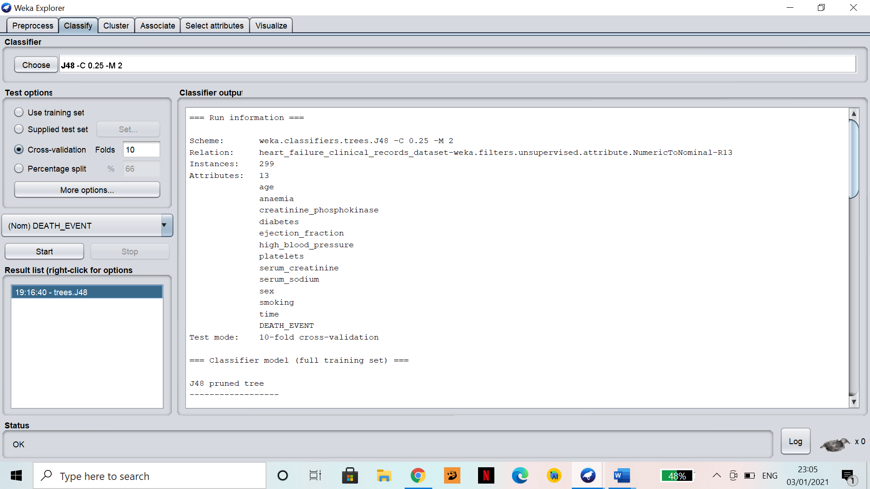

Figure 42.

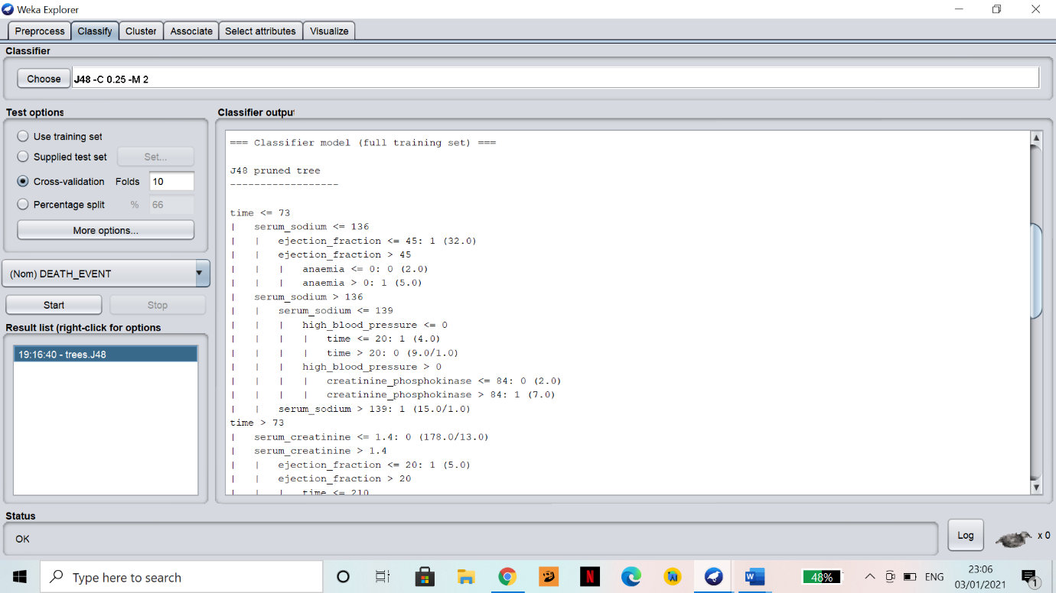

Figure 43.

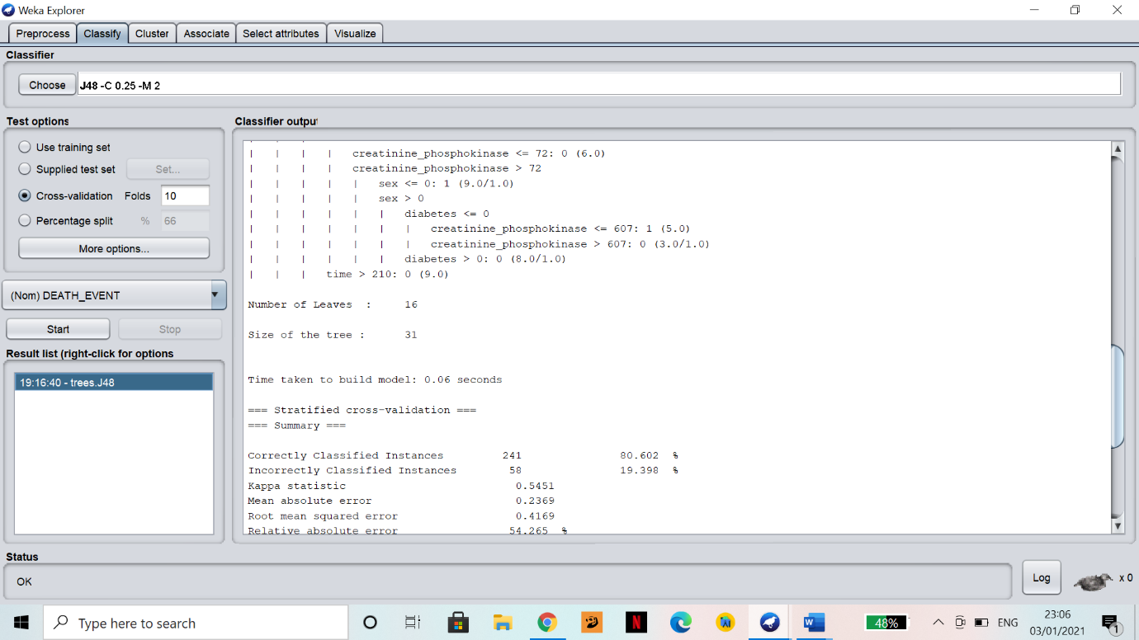

Figure 44.

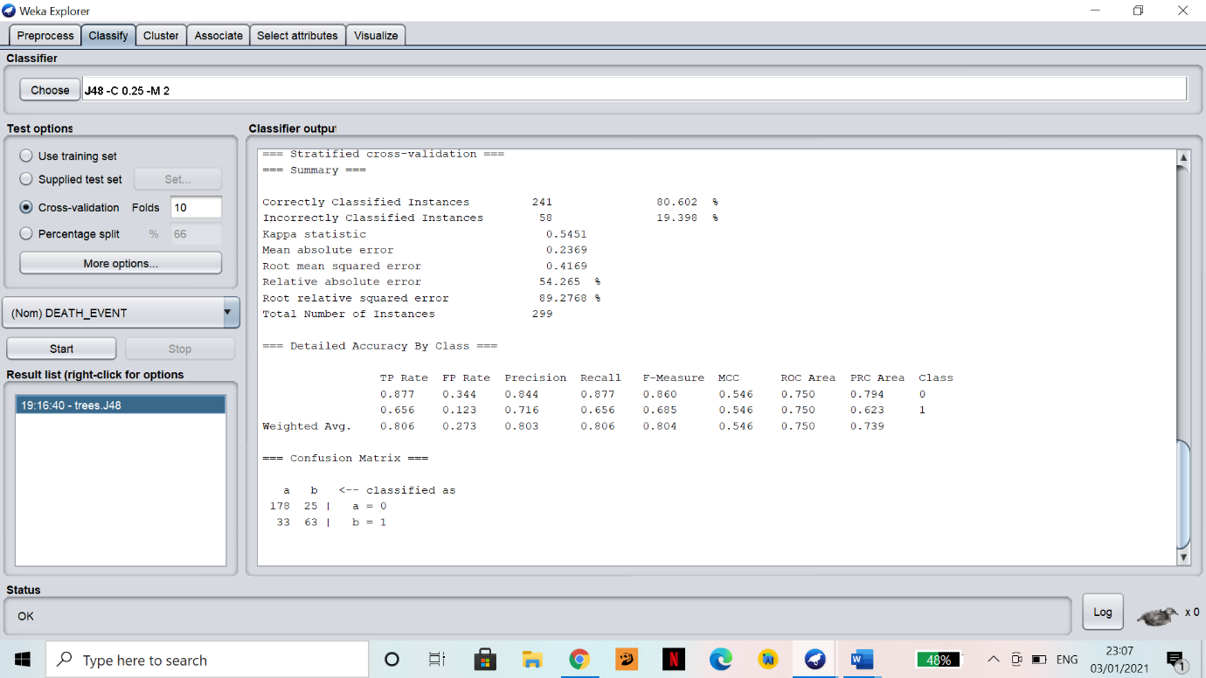

Figure 45.

1. Tree Visualisation

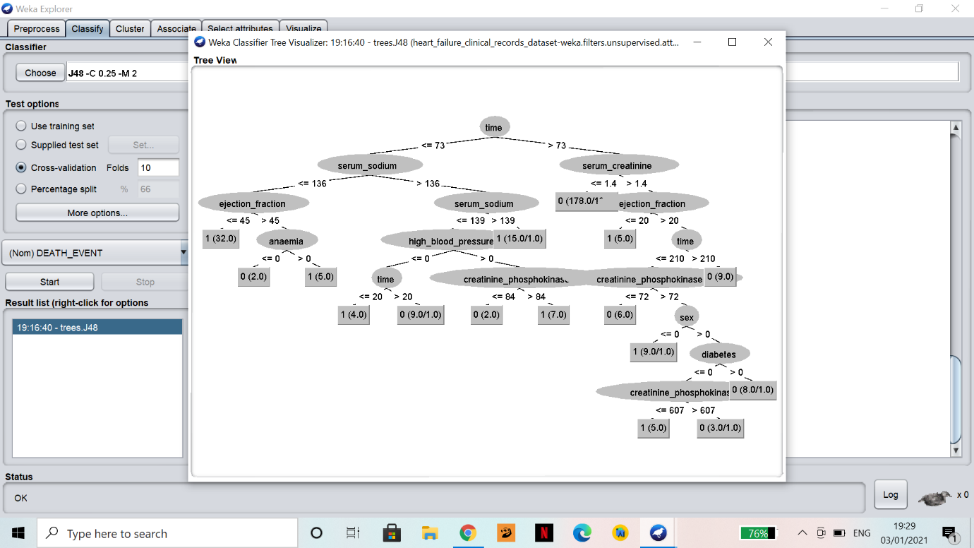

Figure 46.

1. Evaluation

The tree in the previous section (Figure 46) can be used to make predictions by starting at the top. First it checks if time is greater or less than 73, and so on until it gets to a square (leaf) node. If that node is a 1 then the prediction is DEATH_EVENT == yes, or 0 means the prediction is DEATH_EVENT == no.

The "confusion matrix" (Figure 45) in the text output shows total predictions for the whole dataset. Here, 178 were correctly classified as no DEATH_EVENT and 63 were correctly classified as DEATH_EVENT. However, 25 were wrongly classified as no death and 33 were wrongly classified as a death.

Reading the tree from the top tells the most important attributes that can predict the death event, and it looks like time, serum sodium and serum creatinine are the three important attributes. According to the academic paper written based on this dataset, “Serum creatinine was significant with p-value = 0.0026. It means death hazard gets more than double for unit increase in Serum creatinine.” (Ahmad et al., 2017). However, “Serum sodium was significant with p-value = 0.0052 and its one unit (meq/L) increase decreases the hazard by 6%.” (Ahmad et al., 2017). However, in this paper a Cox Regression model based these conclusions and according to that model, CHD and Ejection Fraction were found to be the most significant attributes that determine death event followed by serum creatinine, serum sodium and anaemia.

**References**

**Dataset Citation:**

Dua, D. and Graff, C. (2019). UCI Machine Learning Repository [http://archive.ics.uci.edu/ml]. Irvine, CA: University of California, School of Information and Computer Science.

‌Ahmad, A., Munnir, A., Bhatti, S.H., Aftab, M. and Raza, M.A. (2017). *Survival analysis of heart failure patients: A case study*. [online] Available at: https://journals.plos.org/plosone/article?id=10.1371/journal.pone.0181001 [Viewed on 7 Dec. 2020].

Brownlee, J. (2020). *Tour of Data Preparation Techniques for Machine Learning*. [online] Machine Learning Mastery. Available at: https://machinelearningmastery.com/data-preparation-techniques-for-machine-learning/ [Viewed on 7 December 2020].

Chicco, D. and Jurman, G. (2020). *Machine learning can predict survival of patients with heart failure from serum creatinine and ejection fraction alone*. BMC Medical Informatics and Decision Making, 20(1).

HTQ. (2018). *Creatine phosphokinase (CPK) - normal, high, low*. [online] Available at: https://healthtopquestions.com/creatine-phosphokinase-cpk-normal-high-low/ [Viewed on 7 December 2020].

Kuhn, M. and Johnson, K. (2019). *Feature Engineering and Selection: A Practical Approach for Predictive Models*. 1st ed. p.96-97.

Lybrate. (n.d.). *Creatinine Phosphokinase Test - Test Results, Normal Range, Cost and More*. [online] Available at: https://www.lybrate.com/lab-test/creatinine-phosphokinase# [Viewed on 7 December 2020].

Platelet Boost. *Does Platelet Count Decrease With Age?* [online] Available at: <https://boostplateletcount.com/does-platelet-count-decrease-with-age/#:~:text=This%20can%20cause%20your%20blood%20to%20clot%20inside,point%2C%20yes%2C%20platelet%20count%20does%20decrease%20with%20age>. [Viewed on 13th December 2020].

‌

‌

‌